Week 5
Midterm Lab Exam
Rusudan Kakhishvili
GitHub link:
TASK 1 – AES ENCRYPTION
Task 1A: Encrypt a file using AES-128-CBC
1. Create a text file: secret.txt with the line: This file contains top secret information.
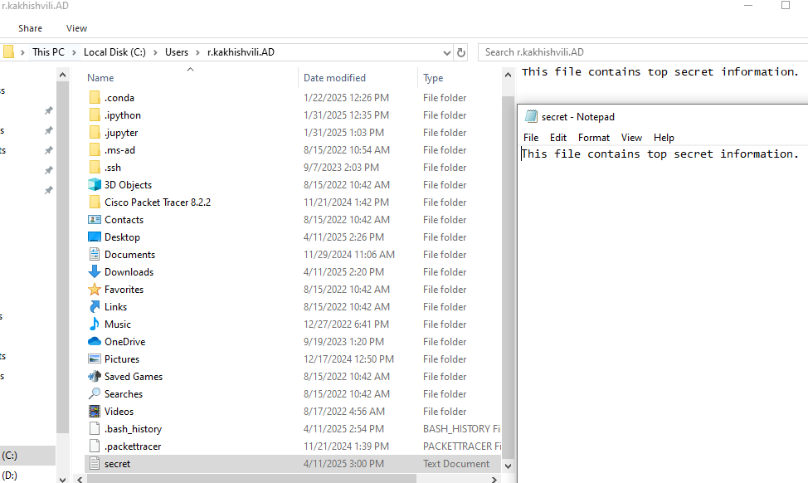
Using the OpenSSL, I created a text file “secret.txt” with the defined text provided within the task and checked if it was created.
Command:
r.kakhishvili@rkakhishvili MINGW64 ~
$ echo "This file contains top secret information." > secret.txt

r.kakhishvili@rkakhishvili MINGW64 ~
$ pwd
/c/Users/r.kakhishvili.AD

Output:
r.kakhishvili@rkakhishvili MINGW64 ~
$ ls
'3D Objects'/ Cookies@ Links/ NTUSER.DAT{8d69c171-ad7c-11eb-8978-b5a11e6bbb52}.TM.blf Pictures/ SendTo@ ntuser.dat.LOG2
AppData/ Desktop/ 'Local Settings'@ NTUSER.DAT{8d69c171-ad7c-11eb-8978-b5a11e6bbb52}.TMContainer00000000000000000001.regtrans-ms PrintHood@ 'Start Menu'@ ntuser.ini
'Application Data'@ Documents/ Music/ NTUSER.DAT{8d69c171-ad7c-11eb-8978-b5a11e6bbb52}.TMContainer00000000000000000002.regtrans-ms Recent@ Templates@ secret.txt
'Cisco Packet Tracer 8.2.2'/ Downloads/ 'My Documents'@ NetHood@ 'Saved Games'/ Videos/
Contacts/ Favorites/ NTUSER.DAT OneDrive/ Searches/ ntuser.dat.LOG1

2. Use OpenSSL to encrypt it with a passphrase of your choice.
Created a paraphrase and encrypted the secret.txt using OpenSSL. My password is quite strong: M*G***C**1**
Command:
r.kakhishvili@rkakhishvili MINGW64 ~
$ openssl enc -aes-128-cbc -salt -in secret.txt -out secret.enc
enter AES-128-CBC encryption password:
Verifying - enter AES-128-CBC encryption password:
*** WARNING : deprecated key derivation used.
Using -iter or -pbkdf2 would be better.

3. Save the encrypted file as secret.enc.
The new file named secret.enc was created.
Output:
r.kakhishvili@rkakhishvili MINGW64 ~
$ ls
'3D Objects'/ Cookies@ Links/ NTUSER.DAT{8d69c171-ad7c-11eb-8978-b5a11e6bbb52}.TM.blf Pictures/ SendTo@ ntuser.dat.LOG2
AppData/ Desktop/ 'Local Settings'@ NTUSER.DAT{8d69c171-ad7c-11eb-8978-b5a11e6bbb52}.TMContainer00000000000000000001.regtrans-ms PrintHood@ 'Start Menu'@ ntuser.ini
'Application Data'@ Documents/ Music/ NTUSER.DAT{8d69c171-ad7c-11eb-8978-b5a11e6bbb52}.TMContainer00000000000000000002.regtrans-ms Recent@ Templates@ secret.enc
'Cisco Packet Tracer 8.2.2'/ Downloads/ 'My Documents'@ NetHood@ 'Saved Games'/ Videos/ secret.txt
Contacts/ Favorites/ NTUSER.DAT OneDrive/ Searches/ ntuser.dat.LOG1

4. Document the commands used.
Creation of file:
r.kakhishvili@rkakhishvili MINGW64 ~
$ echo "This file contains top secret information." > secret.txt
Encryption of file:
r.kakhishvili@rkakhishvili MINGW64 ~
$ openssl enc -aes-128-cbc -salt -in secret.txt -out secret.enc
enter AES-128-CBC encryption password:
Verifying - enter AES-128-CBC encryption password:
*** WARNING : deprecated key derivation used.
Using -iter or -pbkdf2 would be better.

Checke of file location:
r.kakhishvili@rkakhishvili MINGW64 ~
$ ls

Task 1B: Decrypt secret.enc
- Decrypt the file.
I used the passcode that I created in Task1A-2 to decrypted the “secret.enc” file.
Command:
r.kakhishvili@rkakhishvili MINGW64 ~
$ openssl enc -d -aes-128-cbc -in secret.enc -out decrypted.txt
enter AES-128-CBC decryption password:
*** WARNING : deprecated key derivation used.
Using -iter or -pbkdf2 would be better.

- Show that it matches the original.
Checked if the original file sectect.txt and decrypted file matched.
Command:
r.kakhishvili@rkakhishvili MINGW64 ~
$ cat secret.txt
cat decrypted.txt

Output:
This file contains top secret information.
This file contains top secret information.

TASK 2 – ECC SIGNATURE VERIFICATION
Use OpenSSL or Python cryptography/ecdsa libraries.
Task 2A: Generate ECC keys
- Use the prime256v1 curve.
Used the prime256v1 curve to create and save Elliptical curve cryptography (ECC) private key. The file was saved as “ecc_private.pem.”
Commands:
r.kakhishvili@rkakhishvili MINGW64 ~
$ openssl ecparam -name prime256v1 -genkey -noout -out ecc_private.pem

r.kakhishvili@rkakhishvili MINGW64 ~
$ ls

Output:
'3D Objects'/ Cookies@ Links/ NTUSER.DAT{8d69c171-ad7c-11eb-8978-b5a11e6bbb52}.TM.blf Pictures/ SendTo@ ecc_private.pem secret.txt
AppData/ Desktop/ 'Local Settings'@ NTUSER.DAT{8d69c171-ad7c-11eb-8978-b5a11e6bbb52}.TMContainer00000000000000000001.regtrans-ms PrintHood@ 'Start Menu'@ ntuser.dat.LOG1
'Application Data'@ Documents/ Music/ NTUSER.DAT{8d69c171-ad7c-11eb-8978-b5a11e6bbb52}.TMContainer00000000000000000002.regtrans-ms Recent@ Templates@ ntuser.dat.LOG2
'Cisco Packet Tracer 8.2.2'/ Downloads/ 'My Documents'@ NetHood@ 'Saved Games'/ Videos/ ntuser.ini
Contacts/ Favorites/ NTUSER.DAT OneDrive/ Searches/ decrypted.txt secret.enc

- Save private and public keys.
From the above created private key, extracted the public key and saved it as “ecc_public.pem”.
Commands:
r.kakhishvili@rkakhishvili MINGW64 ~
$ openssl ec -in ecc_private.pem -pubout -out ecc_public.pem
read EC key
writing EC key

r.kakhishvili@rkakhishvili MINGW64 ~
$ ls

Output:
'3D Objects'/ Cookies@ Links/ NTUSER.DAT{8d69c171-ad7c-11eb-8978-b5a11e6bbb52}.TM.blf Pictures/ SendTo@ ecc_private.pem secret.enc
AppData/ Desktop/ 'Local Settings'@ NTUSER.DAT{8d69c171-ad7c-11eb-8978-b5a11e6bbb52}.TMContainer00000000000000000001.regtrans-ms PrintHood@ 'Start Menu'@ ecc_public.pem secret.txt
'Application Data'@ Documents/ Music/ NTUSER.DAT{8d69c171-ad7c-11eb-8978-b5a11e6bbb52}.TMContainer00000000000000000002.regtrans-ms Recent@ Templates@ ntuser.dat.LOG1
'Cisco Packet Tracer 8.2.2'/ Downloads/ 'My Documents'@ NetHood@ 'Saved Games'/ Videos/ ntuser.dat.LOG2
Contacts/ Favorites/ NTUSER.DAT OneDrive/ Searches/ decrypted.txt ntuser.ini

Task 2B: Sign and verify a message
- Create ecc.txt with Elliptic Curves are efficient.
Commands:
r.kakhishvili@rkakhishvili MINGW64 ~
$ echo "Elliptic Curves are efficient." > ecc.txt

r.kakhishvili@rkakhishvili MINGW64 ~
$ ls

Output:
'3D Objects'/ Cookies@ Links/ NTUSER.DAT{8d69c171-ad7c-11eb-8978-b5a11e6bbb52}.TM.blf Pictures/ SendTo@ ecc.txt ntuser.ini
AppData/ Desktop/ 'Local Settings'@ NTUSER.DAT{8d69c171-ad7c-11eb-8978-b5a11e6bbb52}.TMContainer00000000000000000001.regtrans-ms PrintHood@ 'Start Menu'@ ecc_private.pem secret.enc
'Application Data'@ Documents/ Music/ NTUSER.DAT{8d69c171-ad7c-11eb-8978-b5a11e6bbb52}.TMContainer00000000000000000002.regtrans-ms Recent@ Templates@ ecc_public.pem secret.txt
'Cisco Packet Tracer 8.2.2'/ Downloads/ 'My Documents'@ NetHood@ 'Saved Games'/ Videos/ ntuser.dat.LOG1
Contacts/ Favorites/ NTUSER.DAT OneDrive/ Searches/ decrypted.txt ntuser.dat.LOG2

- Sign it with your private key.
Command:
r.kakhishvili@rkakhishvili MINGW64 ~
$ openssl dgst -sha256 -sign ecc_private.pem -out ecc.sig ecc.txt

- Verify it using your public key.
Verified that the signature is valid with the public key.
Command:
r.kakhishvili@rkakhishvili MINGW64 ~
$ openssl dgst -sha256 -verify ecc_public.pem -signature ecc.sig ecc.txt

Output:
Verified OK

TASK 3 – HASHING & HMAC
Task 3A: SHA-256 Hash
- Create data.txt with: Never trust, always verify.
Created file, saved it and checked its content.
Commands:
r.kakhishvili@rkakhishvili MINGW64 ~
$ echo "Never trust, always verify." > data.txt

r.kakhishvili@rkakhishvili MINGW64 ~
$ ls

Output:
'3D Objects'/ Cookies@ Links/ NTUSER.DAT{8d69c171-ad7c-11eb-8978-b5a11e6bbb52}.TM.blf Pictures/ SendTo@ decrypted.txt ntuser.dat.LOG1
AppData/ Desktop/ 'Local Settings'@ NTUSER.DAT{8d69c171-ad7c-11eb-8978-b5a11e6bbb52}.TMContainer00000000000000000001.regtrans-ms PrintHood@ 'Start Menu'@ ecc.sig ntuser.dat.LOG2
'Application Data'@ Documents/ Music/ NTUSER.DAT{8d69c171-ad7c-11eb-8978-b5a11e6bbb52}.TMContainer00000000000000000002.regtrans-ms Recent@ Templates@ ecc.txt ntuser.ini
'Cisco Packet Tracer 8.2.2'/ Downloads/ 'My Documents'@ NetHood@ 'Saved Games'/ Videos/ ecc_private.pem secret.enc
Contacts/ Favorites/ NTUSER.DAT OneDrive/ Searches/ data.txt ecc_public.pem secret.txt

Command:
r.kakhishvili@rkakhishvili MINGW64 ~
$ cat data.txt

Output:
Never trust, always verify.

- Hash it using Python or CLI.
Gained SHA-256 hash output.
Command:
r.kakhishvili@rkakhishvili MINGW64 ~
$ openssl dgst -sha256 data.txt

Output:
SHA2-256(data.txt)= 1d7834c9c74c6f7560d4e77eb03039389e377ba5ad480970d31ebdc4205df9b3

3. Submit hash output and code/command.
Have conducted in the above steps.

Task 3B: HMAC using SHA-256
- Use the key: secretkey123
Command:
r.kakhishvili@rkakhishvili MINGW64 ~
$ openssl dgst -sha256 -hmac "secretkey123" data.txt

Output:
HMAC-SHA2-256(data.txt)= e550e820ecb5c998a1dadf897085dd60c059c3347d26335d7a6fff85d4d3416a

2. Create an HMAC for data.txt.
Command:
r.kakhishvili@rkakhishvili MINGW64 ~
$ openssl dgst -sha256 -hmac "secretkey123" data.txt

Output:
HMAC-SHA2-256(data.txt)= e550e820ecb5c998a1dadf897085dd60c059c3347d26335d7a6fff85d4d3416a

Task 3C: Integrity Check
- Change one letter in data.txt.
Commands:
r.kakhishvili@rkakhishvili MINGW64 ~
$ echo "Never trast, always verify." > data.txt

r.kakhishvili@rkakhishvili MINGW64 ~
$ cat data.txt

Output:
Never trast, always verify.

- Recompute HMAC.
Ran the HMAC command
Command:
r.kakhishvili@rkakhishvili MINGW64 ~
$ openssl dgst -sha256 -hmac "secretkey123" data.txt

Output:
HMAC-SHA2-256(data.txt)= f818c4afc47d2a948e1b72fda11c9ec653fd7e04617aa16cc6232e73c0e79257

- Explain what happens and why HMAC is important.
The original HMAC gained from Task3B (e550e820ecb5c998a1dadf897085dd60c059c3347d26335d7a6fff85d4d3416a) changed after I changed one letter in file named data.txt, and in Task 3C, I got a different HMAC value (f818c4afc47d2a948e1b72fda11c9ec653fd7e04617aa16cc6232e73c0e79257). Overall, a secret key and the contents of the file were used to calculate HMAC. Because of the characteristics of the SHA-256 hash function, a single character change in the file altered the entire HMAC.
HMAC is crucial because it protects data integrity by detecting tampering or inadvertent changes, authenticates the source by requiring the proper secret key to generate a valid HMAC, and alerts to data alteration or incorrect key use when the HMACs do not match.

